**An invitation to submit invitation to host ECND 2026**

Dear EONS Society Member,

European Oncology Nursing Society organises each year the **European Cancer Nursing Day (ECND)** on 18 May to honor the invaluable contributions of cancer nurses across Europe.

ECND serves as a platform to raise awareness about the challenges and opportunities within the profession, while fostering collaboration among healthcare professionals, policymakers, and the public. This day is also a call to action to shape the future of cancer care, advocating for policies that support nurses' well-being, professional development, and contributions to research.

For more information about this event please visit

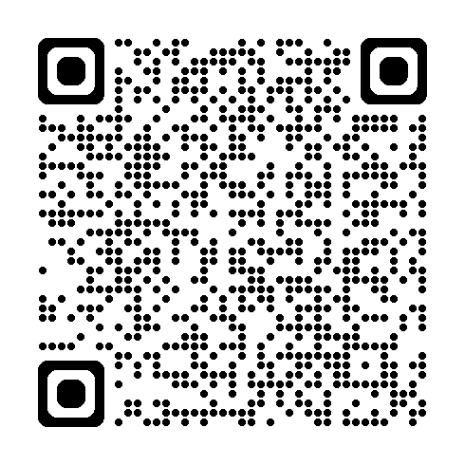

We are pleased to announce that preparations for **ECND 2026** are officially underway. We would like to invite applications from our National Member Oncology Nursing Societies, interested in hosting and organizing this event in cooperation with the EONS ECND Task Group.

The National Oncology Nursing Society may propose a maximum of two destinations in their country which have:

* easy access (air, rail, road)
* the required hotel accommodation with minimum 80 rooms capacity and five meeting room possibilities for our working groups (if the meetings will be organized in the same venue)
* venue location ( convention hotel/University venue) with the required capacity (Five EONS working Group meetings)

The ECND in person event (1 day) will take place on **(dates to choose between 15th-17th) of May 2026**. The ECND event can be organised as an event attached on national society own event (Annual Conference or similar).

Host Society

The candidate Society should nominate a **Local National Society Representative** to serve as the primary contact person with EONS.

* + Expressions of interest must include the following details:
  + **- Motivation** for hosting the **ECND 2026** event.
  + **- Rationale** for selecting your city, region, or country as the host location, including opportunities to foster engagement with the profession at local and national levels, and/or to create synergies with your own national congress.
  + - The **anticipated level of local participation and support**, outlining how your national society or local nursing community can contribute to:
  + Organising social events (including liaison with local authorities),
  + Attracting exhibitors and sponsors.

# Bidding procedure

All **expressions of interest** must be submitted **by 15th October** and sent electronically to both:

**Nikolina Dodlek** – [nikolina.dodlek@cancernurse.eu](mailto:nikolina.dodlek@cancernurse.eu)

**EONS Chief Operating Officer –** [malika.denolf@cancernurse.eu](mailto:malika.denolf@cancernurse.eu)

Submissions should include all information requested in the **Event Proposal Template** and the **ECND 2026 Offer Template**, which are provided as separate attachments.

It would be highly valuable to include **additional information, links, and images** showcasing potential hotels and meeting venues.

The EONS Board will review all submitted offers and make its final decision during the November board meeting.

Should you have any questions on the above please do not hesitate to contact us.